Resources
SolidWorks, SolidWorks Simulation, MATLAB Simscape Multibody, URDF, 3D Printer
Progress
Quadruped Mechanical Design, Structural Analysis, Gait Simulation, Flat/Incline/Decline Motion Analysis, PID & Fault Simulation, 3D Printing
Blockers
3D printing of remaining components
Dependency / Chain
Completion of 3D printing and mechanical assembly
Approval Dependency
Yes
Partial Ownership
No
Complete Ownership
Yes
Owner
Manya Shukla
Contributor
No
Next Action
Complete remaining 3D-printed components, assemble the quadruped and proceed with hardware integration and physical testing.
Evidence
CAD files, simulation results, motion-analysis results, structural-analysis plots and 3D-printed components.
Status
In Progress

CAD Screenshots:
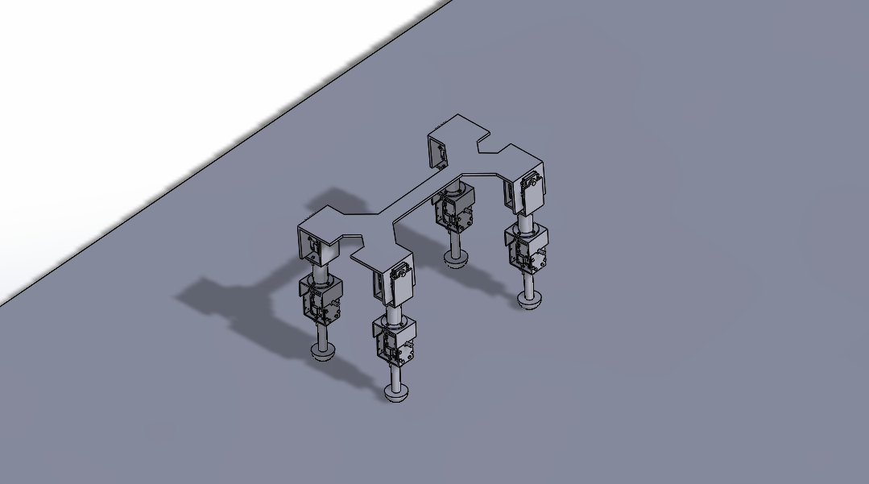
BOM:
ITEM NO. | PART NUMBER | DESCRIPTION | QTY.
1 | Ground | Reference ground/base for robot assembly and simulation. | 1
2 | H Frame1 | Main chassis frame supporting the quadruped legs. | 1
3 | RX_64 | Servo actuator for the hip/main leg joint. | 4
4 | c bracket | Mounting bracket for RX-64 servo. | 4
5 | disc(1) | Circular joint disc for mechanical connection and motion transfer. | 8
6 | link1 | Upper leg link connecting the hip and knee assemblies. | 4
7 | c bracket2 | Mounting bracket for RX-28 servo. | 4
8 | RX_28 | Servo actuator for the knee joint. | 4
9 | C bracket 3 | Support bracket for the lower joint assembly. | 4
10 | Smaller Disc | Circular disc for lower joint connection and motion transfer. | 4
11 | lower link | Lower leg link connecting knee to foot. | 4
12 | Foot | Ground-contact component supporting the robot. | 4
13 | IS 1364 HHB(Grade  A) - M2.5 x 16 x 11-N | Hex-head bolt for component fastening. | 96
14 | nut2.5 | Nut for securing M2.5 fasteners. | 96

ACTUATOR MAPPING:
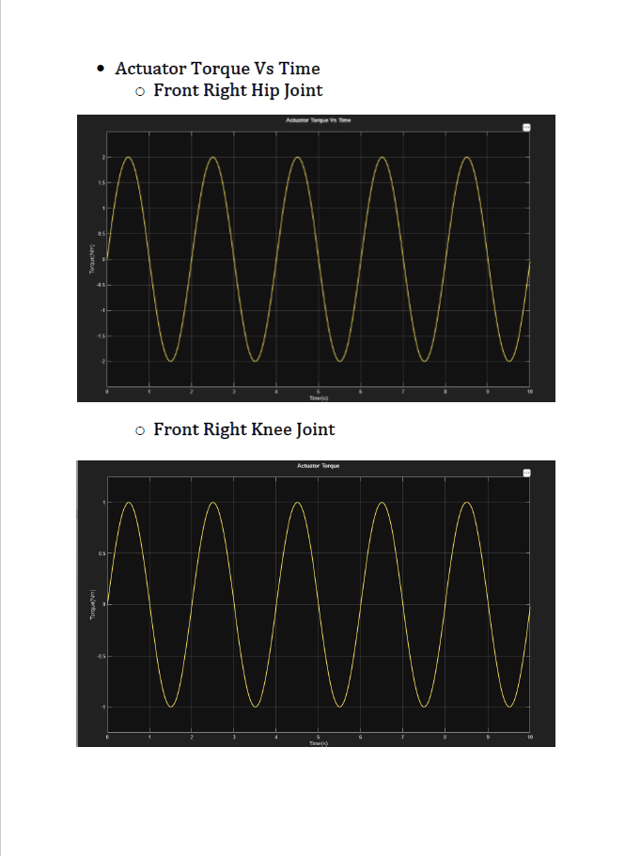

Control Loop Simulation:
